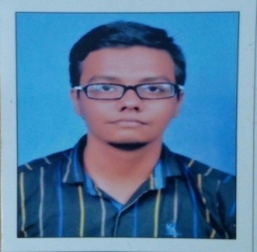
NAME: ANKIT SHAH
ADDRESS: 104-vrund flat, vaikunth -1 waghodiaroad vadodara
CONTACT NO. : 9099406292 EMAIL ID : shahankit232@gmail.com
OBJECTIVES:

To obtain professional and technical excellence through sincerity and hard work in professional and caring organization that provides a promising career progression.
PROFESSIONAL EXPERIENCE:

- Company Name: INDUSIND BANK
- Designation: Relationship Officer
- Duration : 02/05/2016 to till Date
- Job Profile : Sales of Bank Casa Products
- Company Name: Hindustiantimes media.
- Designation: sales Executive
- Skill learn: Teamwork, Communication, Consumer behaviour
Duration: 45 day
STRENGTH / SKILLS:

EDUCATIONAL QUALIFICATION:

- Confident candidate having a powerful grip in context to MARKETING fields.
- Always believe to work hard in order to succeed with in the life but keeping the positive attitude side by side.
- Computer Skills,M.S. Office (M.S.Word, M.S.Power Point, M.S.Excel)
- Hard working & Quick learner
- Team work

SR NO | DEGREE | BOARD / UNIVERSITY | YEAR | % | SPECIALIZATION
1 | MBA | GTU/ Parul institute of management. | - | Pursuing | marketing
2 | BBA(special) | SPU/Amcost | 2013 | 5.35 CGPA | marketing , HR
3 | H.S.C. | GSHSEB/ Highschool.savli | 2010 | 48.71 | Commerce
4 | S.S.C. | GSEB/Gangotri school savli | 2008 | 46.31

ACHIEVEMENTS:

Participated in business bazigar event at M.S.U in 2012
Participated in VCCI(Vadodara chamber of commerce&industry) in 2014
Participated in G.T.U TECHFEST in 2015

PERSONAL DETAILS:

- DATE OF BIRTH : 22 march 1993
- MARITAL STATUS : Single
- GENDER : Male
- NATIONALITY : Indian
- LANGUAGE KNOWN :English,Gujarati, Hindi

DATE :
PLACE :
CONFIRMATION :
SIGNATURE :

